System Guide and Maintenance

for

DTCC Toner Inventory System



Team Coffee House

4/9/2019

CS214

Delaware Technical Community College – DE

**Table of Contents**

**Introduction**..................................................................................................  **1**

**Installation** .................................................................................................... **2**

**Maintenance** ................................................................................................. **3**

System Installation

The DTCC Toner Inventory System is an application designed on the Windows 10 operating system. This means, that all further installation and setup with be done through the Windows 10 operating system.

The DTCC Toner Inventory System was developed using the Eclipse Photon IDE environment Version no. --------------. To begin the installation, Eclipse Photon should be installed on the computer being used in the first step. NOTE: A copy of Eclipse Photon can be downloaded from Eclipse’s official website: <https://www.eclipse.org/downloads/download.php?file=/oomph/epp/photon/R/eclipse-inst-win64.exe>. (*After the download is complete, users can run the program and go through a series of actions that will install the eclipse IDE filed to the selected computer).* Various build dependencies were used during the creation of this project, these dependencies consist of JUnit 5 for testing, and (JavaFX SDK or e(fx)clipse) for the GUI application. Please see below on installation instructions.

[***JUnit 5:*** *Included in Eclipse Photon, in order to include in your project, right click your project, hover over “Build Path”, and select “add libraries”. After, you should see a list of dependencies, one of which is JUnit. Select JUnit and click “Next”. Select JUnit library version as “JUnit 5”, then click finish.]*

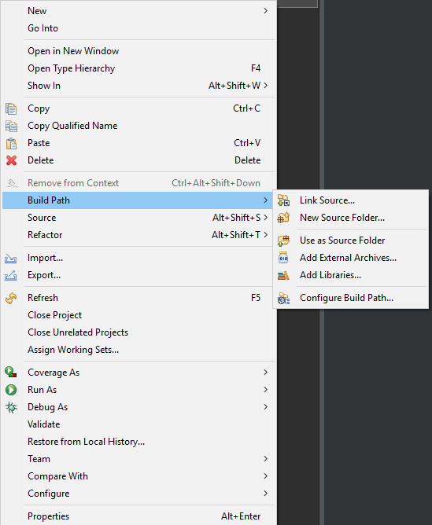

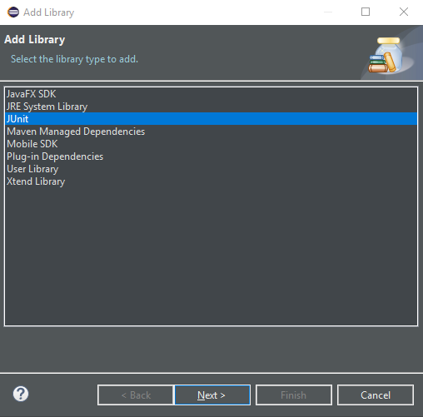

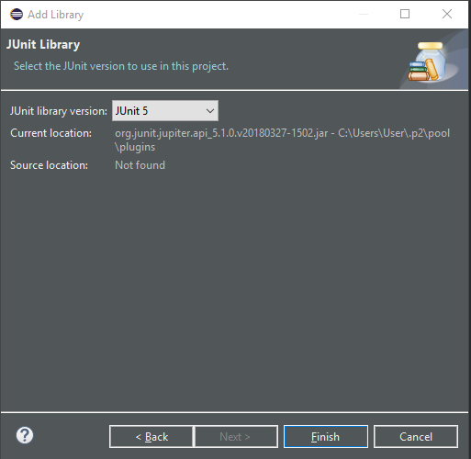

*[****JavaFX SDK:*** *In your Eclipse Photon there is a menu bar at the top. Select Window then scroll until you see preferences. After selecting preferences you will have a new window pop up with various options. Scroll down until you see the option “Java” and double click that opening more hidden options. Look for “Build Path” and double click that option, next you will see another set of options. Select “User Libraries”. You will see a window which should be empty or contain Java “JRE System Library”. Select this and click the remove button to the right. Next, select “New” and create a new library named “JavaFX” (the naming is optional but for the purposes of installation we will call it JavaFX). After the library is created select the library and click the button to the right that says “Add External Jars”. Clicking this button will open up your file system and you will now have to navigate to your JDK folder under “Java” (this is typically under your C: drive within the “program files” section of your file system). After you get to your JDK file, navigate to the JRE file and then LIB. In the LIB file you will see multiple .jar files, select the one named “jfxswt.jar” and click the Open button.]*

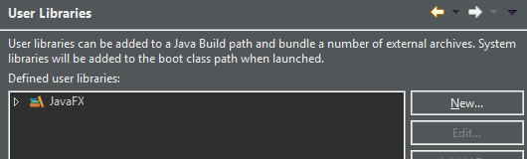

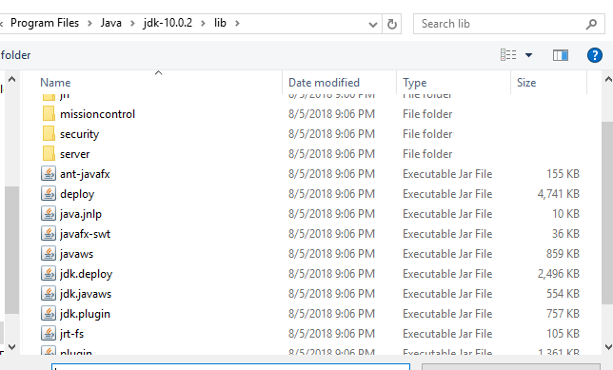

*[****(e(fx)clipse):*** *In your Eclipse Photon there is a menu bar at the top. Hover over “Help” and select “Install New Software”. Within the “Work with:” box of text, delete the current text and paste in* [*http://download.eclipse.org/efxclipse/updates-released/1.2.0/site/*](http://download.eclipse.org/efxclipse/updates-released/1.2.0/site/)*. Next name your repository (for this installation we will name it e(fx)clipse). After naming the repository, click OK. This will bring up a new window and you will see a few options within the installation option box, under the installation box you will see a button called “Select All”, click that button then to the right of the window click “Next”. On the following window you will see installation details, we will not be concerned with this, click “Next”. The following window will bring you to the terms and conditions of the plugin/dependency, first read the terms and conditions, then tick the box labeled “I accept the terms of the license agreements”, and click “Finish” at the bottom of the window. After the installation you will need to restart your Eclipse IDE]*

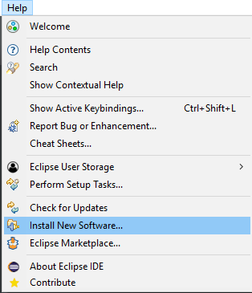

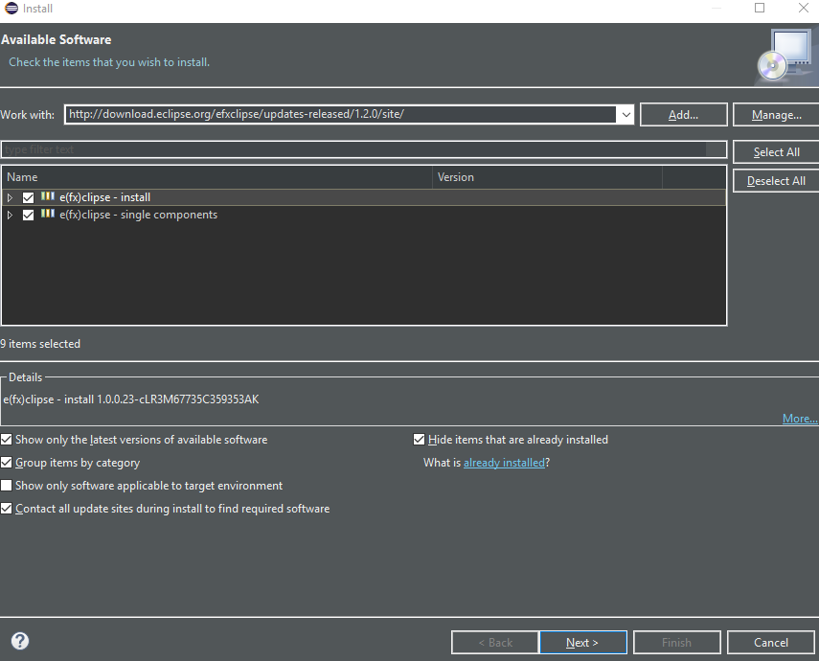

Now that Eclipse Photon is platform has been installed on your machine, the DTCC Toner Inventory System application can be downloaded from the online repository. You can download the project from: <https://github.com/dclenden/Toner-Inventory-System/tree/master/application>.

Once a copy of the project has been exported to your local system, locate the directory you chose and right click and select copy on the exported project. Next, launch Eclipse Photon, after Eclipse has finished launching, navigate to the top right of your screen, where you will see “Workspace”, click this button. Doing this should change the view of your screen. At the top of the program you will see a menu bar, click the first option on the menu bar labeled as “File”. After you click this option you will see a menu, hover over “New”, and select “Project”. Next scroll to the folder labeled “JavaFX”, right click this folder. A series of options will appear, one of which is “JavaFX Project”, click this and select “Next” at the bottom of the window. The next window will indicate a name, create a name and select “Finish” at the bottom of the window.

Open your downloaded project from github open the project “Toner-Inventory-System”, select all of the items within the file and right click, then select “Copy”. Next within your Eclipse IDE, open the project you created, and right click, then select “Paste”, all of the contents within the project should be copied over to your JavaFX project within Eclipse and you are now ready to begin working on the project.

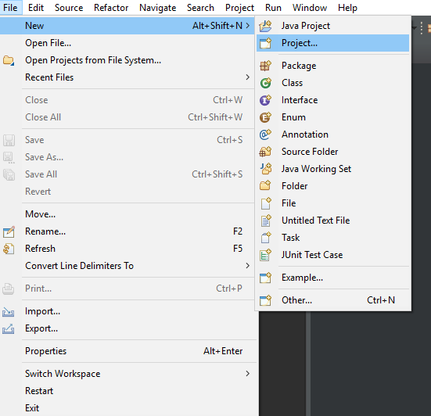

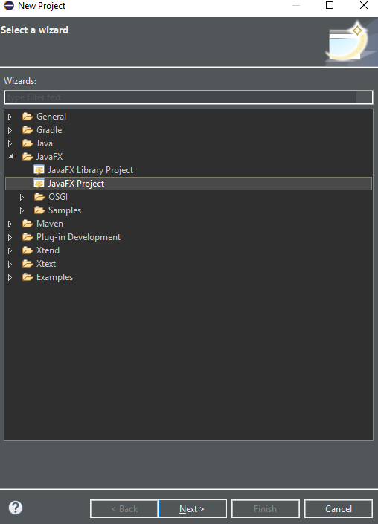

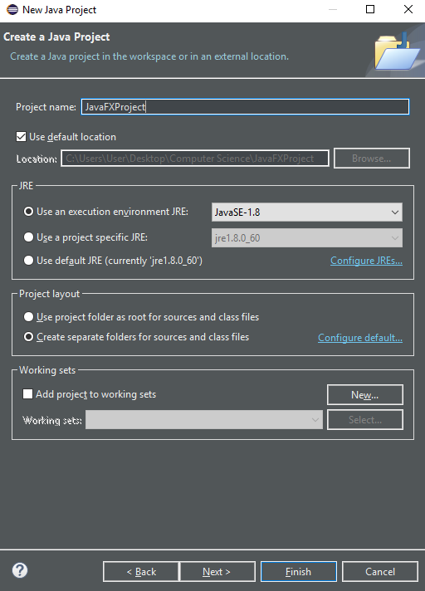

System Maintenance

If any maintenance, changes, or additional functionality needs to be made to the DTCC Toner Inventory System, it is helpful to know some of the ins and outs of the code and to be made aware of some of the specifics of the code. This section of the document will go into a bit of detail on some parts of the project to help the maintenance person understand the project.Because this project is a 3-tier project, this discussion of the code will be grouped into the three different tiers of the architecture.

Front End/GUI

The visual interface of this project consists of 3-6 forms of which the user will navigate through to perform the various operations in the DTCC Toner Inventory System. All GUI functionality is within the “Application” directory (located under the “src” folder). Each form has two files associated with each form, a .fxml file and a Controller.java file. These files are split up to describe different functionality of the overall GUI. The .fxml files hold the parts that make up the forms, such as the local variables and all the pieces that make up what we know as a GUI: text, text boxes, menu items, tables, etc. The Controller.java files will perform operations on the backend based off of the various ActionEvents that will occur according to the users input. Above all of these various files there will be a .css file in which describes the appearance of the project, and how each component of the GUI is styled.

Of the forms in this project there is one that stands out. The most critical form is the “Main” view form. This form is going to be the main view of the program and the starting screen for the end user. This form will be connected to the “MainController.java” class, in which all of the various operations from the user may be handled. The key functionality of this Controller comes from the CSV_DBIMP object named “dao” (data access object). The dao object, will be performing the connection between the back end and the GUI. (Main view is depicted below)

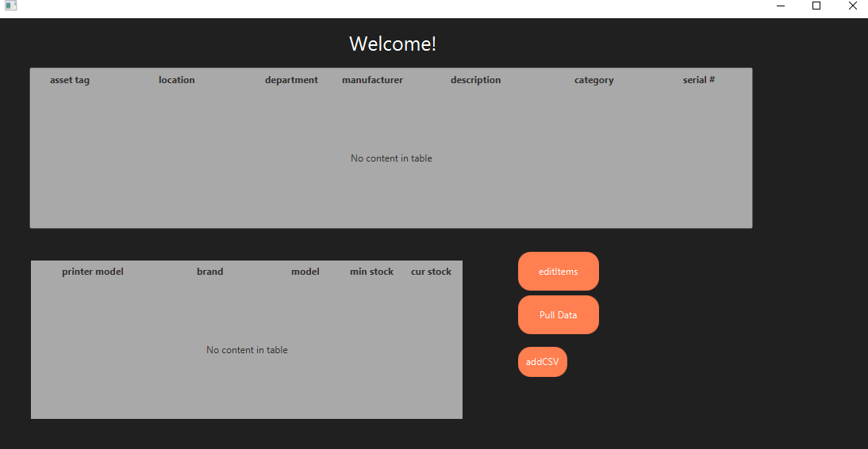

The various other forms are supporting forms, and will be interacted with through the main form, these forms also have their own Controller.java class, but with interact with the MainController.java class in order to perform operations through the static dao. (Other forms depicted below)

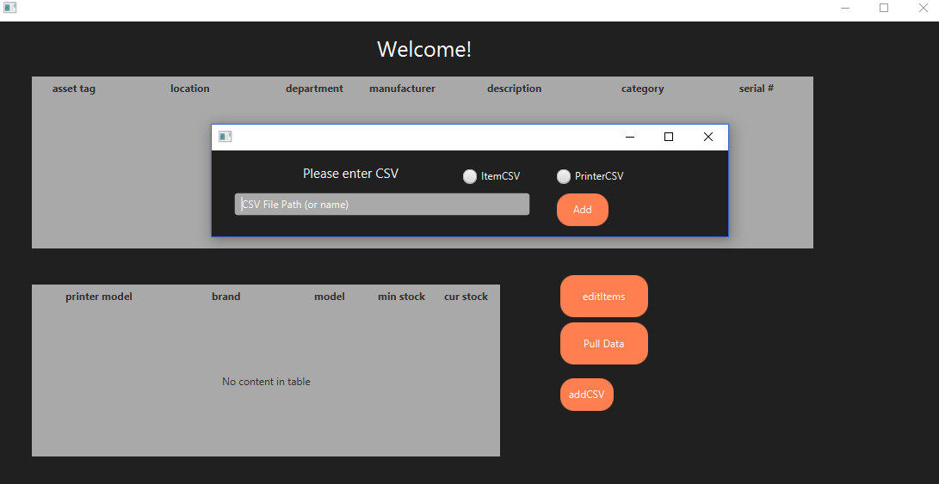

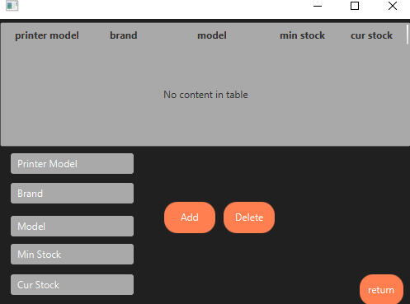

It is essential that the maintenance team understands that the GUI side of the application talks directly with the business logic side of the project, and there is dynamic interaction between them, such as passing Item/Printer CSV’s through the dao. This and the aforementioned information about the GUI side of the application is to help the maintenance person understand the relationships involved so that he/she can be careful about changing the code and knowing where to be careful.

Business Logic/General Classes

The business logic subsystem of the application is between both the GUI side and the data side of the 3-tier architecture, and so it is critical that you are mindful how these systems interact with each other. Although this portion of the system isn’t the most complex, it will still require some dissection to fully understand the system as a whole in order to maintain it.

The general classes of this project are containers for the data extracted from the various CSV files that are to interact with this program, these files are located under the “InventorySystem” directory and each .java file will have an associate interface that is implemented alongside the class. At the highest level of this system stands the CSV_DBIMP.java class. This class contains the functionality of parsing the CSV files for the Printer and Item objects, while also containing the objects that hold that said data in an array. The only unique thing about the CSV_DBIMP.java class is that there is design pattern that allows for only one instance of the class that will act as the bridge between all components. This will ensure that the data within the object is static amongst all components within a single object, so that all data is the same amongst all components.

The only other classes consist of ItemImp.java, TonerImp.java, and PrinterImp.java, these classes are to provide functionality to it associated objects and act as containers that will be handled within the main class CSV_DBIMP.java.

These aspects of the business logic classes are the only things to make note of when doing any sort of maintenance to the application. The things to keep in mind is that CSV_DBIMP is to have one instance and act as a bridge amongst all components, while the other general classes are containers for the various objects of the program and contain minimal functionality as well as the associated getters and setters.

Database and Backend

The physical database is created within the code and is implemented using the various CSV files. In order to retrieve the data from the CSV’s you will have to call the readItemCSV & readPrinterCSV functions on the data access object with a parameter of the CSV file path (or have a file path already determined via the “storeCSV” functions). The database is created in the CSV_DBIMP.java class and is implemented with an instance of this class; the data that is inserted into the data access object is extracted from the various CSV files and is stored in a Item / Printer container object. Within this file there are the various functions that are used to interact with the data that is stored within the data access object.

The CSV_DBIMP class is a dual class that will deal with both the back end operations between classes and the data interaction between the various CSV files. These files will be extracted to the itemList array and the printerList array within the data access object. These arrays will contain a list of its respective object type that will have the attributes extracted from the CSV files.